PENNICOTT
CHARTERED SURVEYORS
ESTABLISHED 1949
Property Particulars
1 Peach Street, Wokingham, Berkshire RG40 1XJ

Tel: 0118 979 8118 Fax: 0118 979 8228
E-mail: surveys@pennicott.com Web www.pennicott.com

BEAUTIFULLY PRESENTED PERIOD OFFICES

MARKET PLACE, WOKINGHAM
(with good on-site car parking)

1,050 sq ft

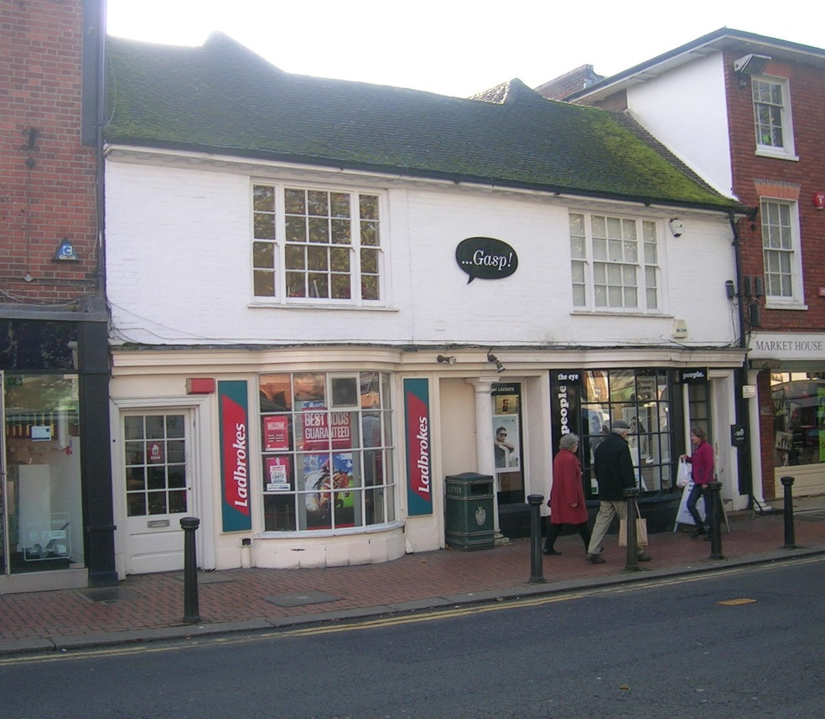

An opportunity to acquire charming period office space
with a delightful outlook over the Market Place.
Description: A suite of period offices centrally situated in the Town’s Market Place arranged largely over the first floor with one additional office/store at second floor level.

Accommodation: The accommodation offers self-contained ground floor access from Market Place leading into a range of office rooms at first floor level including kitchen/staff room/store plus male and female WCs.

Amenities: * Carpeted throughout * Dimplex radiators
* Spotlights * On-site car parking
* Part timber framed * Male/Female WCs
* Alarm

Terms: The premises are offered on a new lease for a term to be agreed.

Legal Costs: Both parties to pay their own costs.

Viewing: By prior appointment with the joint sole agents:

PENNICOTT LIMITED

pennicott.commercial@gmail.com

FRYER COMMERCIAL

07836 519613
sfryer@fryercomm.com

SEG/1958/Oct 2020

You should be aware that the Code for Leasing Business Premises in England and Wales strongly recommends you seek professional advice from a qualified surveyor, solicitor or licensed conveyancer before agreeing or signing a business tenancy agreement. The Code is available through professional institutions and trade associations or through the website: www.leasingbusinesspremises.co.uk

