Rateable Values (2017 List):
12c | £13,680
12d | £12,360
12a | £13,800
Uniform Business Rate multiplier (2019-2020) 49.1 pence
Tenure
New leases are available from the landlord on terms to be agreed.
epc
E105
legal costs
Each party is to pay its own legal costs.

- Suites from 2,436 sq ft. to 7,617 sq.ft.
- Modern office building
- Excellent onsite parking
- Potential for alternative commercial uses
- Suitable for owner occupation/ partial investment

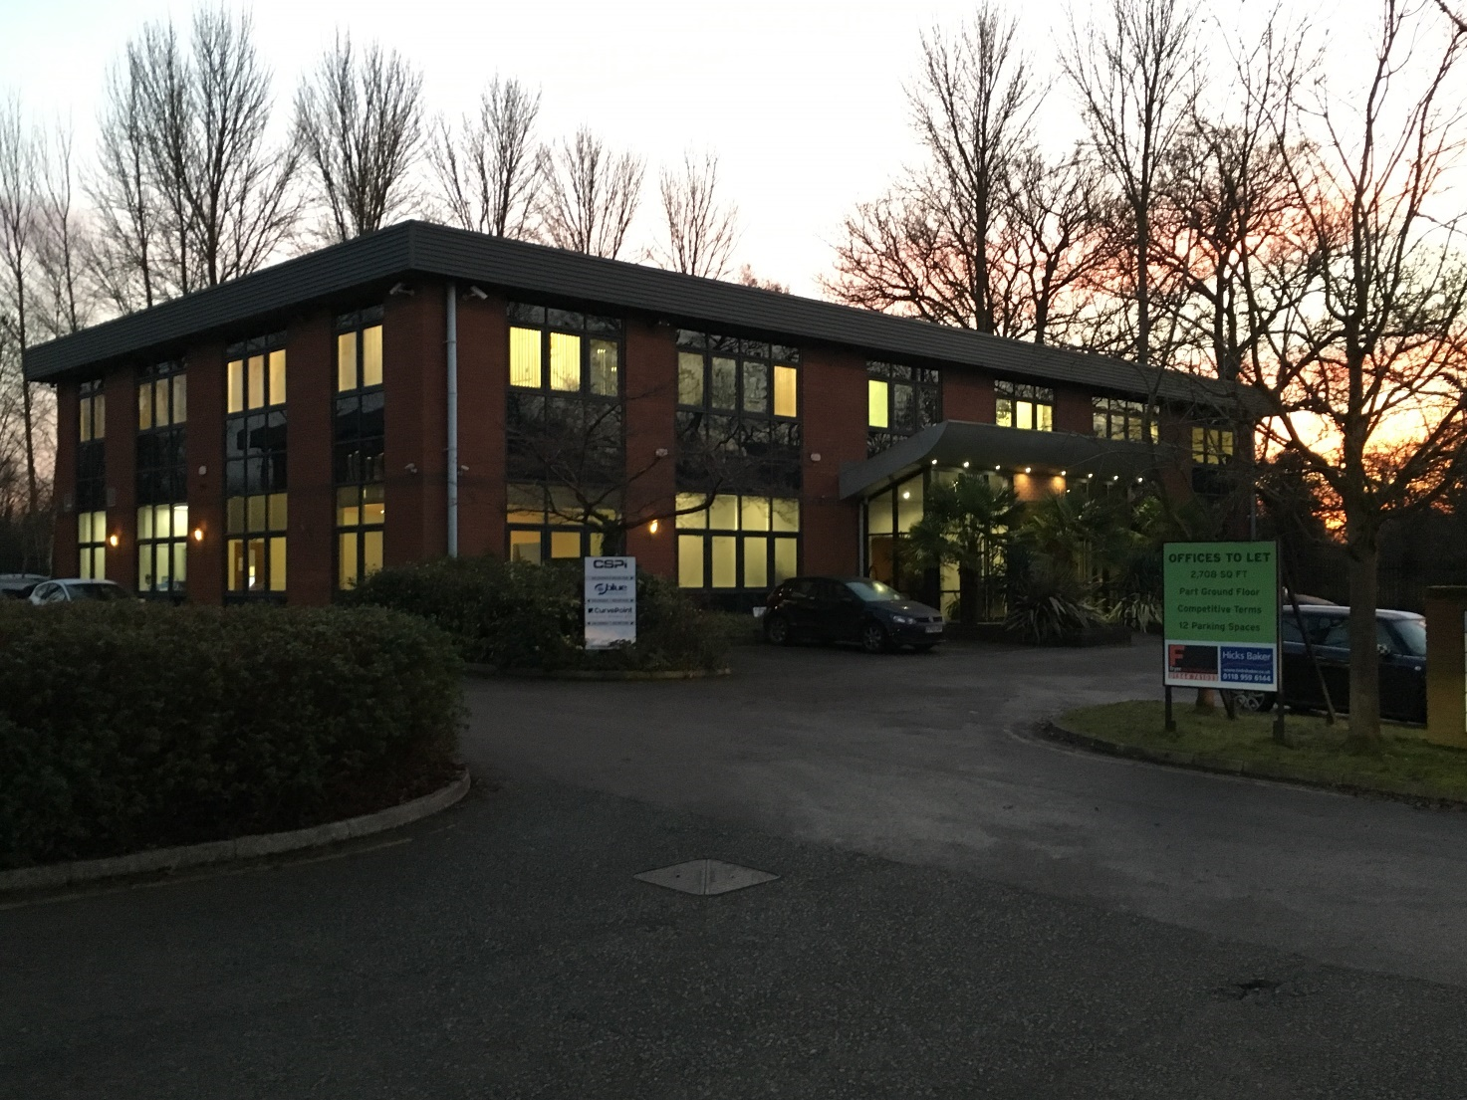
Wokingham - 12 Oaklands Park, RG41 2FD
OakOReading – 50 Queens Road, RG1 4AU
OFFICEs TO LET

RENT: £17.00 per sq.ft.
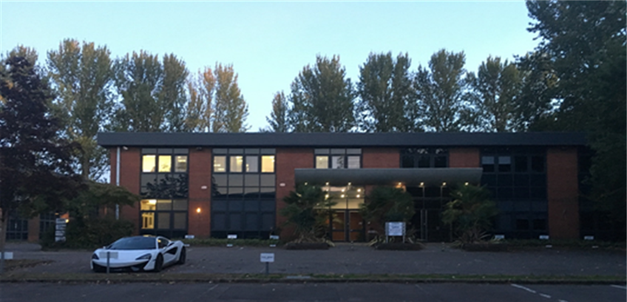
Description

12 Oaklands Park is a two storey, self-contained building on a site of circa 0.5 acres with a total of 44 parking spaces (a ratio of 1:268 sq.ft.) The property is currently sub-divided into four individually lettable office units. The property is located on Oaklands Park, accessed via Molly Millar’s Lane and Fishponds Road.

Location

Wokingham town centre is within walking distance and provides a wide range of amenities including shops, restaurants, bars, a library, swimming pool and several gyms. The area is currently undergoing a major redevelopment which will add to local facilities (including a cinema complex) and significantly improve traffic flows. Completion is expected late 2019.

Frequent train services are available to Reading (8 minutes) from which connections can be made to London Paddington (26 minutes). There are direct trains from Wokingham to London Waterloo with a journey time of 68 minutes. Wokingham is also well connected by road, being accessible from M4 J10 via the A329(M) and M3 J3 via the A322.

Site Plan

Availability

FLOOR | UNIT | Size sq ft | S/C pa | Availability
Ground | 12c | 2,436 | £7,125 | Now
 | 12d | 2,708 | £10,000 | July 2020
First | 12a | 2,473 | £12,140 | Now
TOTAL |  | 7,617 | £37,453

VIEWINGS AND MORE INFORMATION
Harry Gornall-King | Tom Mudie | Simon Fryer
Hicks Baker | Hicks Baker | Fryer Commercial
T: 0118 955 7075 | T: 0118 955 7086 | T: 01344 741033
E: h.gornall-king@hicksbaker.co.uk | E: t.mudie@hicksbaker.co.uk | E: sfryer@fryercomm.com

